**Structure of US Banking System**

The U.S. banking sector is complex and diverse, consisting of various types of institutions that provide a wide range of financial services. Here's a detailed overview of its structure:

1. **Central Bank: The Federal Reserve System**

* **Federal Reserve (the Fed)**: The central bank of the United States, established in 1913.
  + **Board of Governors**: Seven members, including the Chair and Vice-Chair, appointed by the President and confirmed by the Senate.
  + **Federal Reserve Banks**: Twelve regional banks located in major cities across the U.S., each serving its district.
  + **Federal Open Market Committee (FOMC)**: Comprises the Board of Governors and five of the twelve regional bank presidents. It oversees open market operations and sets monetary policy.

**2. Commercial Banks**

* **Large National Banks**: Operate nationwide and offer a full range of services, including retail, commercial, and investment banking.
  + Examples: JPMorgan Chase, Bank of America, Citigroup, Wells Fargo.
* **Regional Banks**: Operate in specific regions and offer similar services to national banks but on a smaller scale.
  + Examples: U.S. Bancorp, PNC Financial Services, BB&T (Truist).
* **Community Banks**: Smaller banks that focus on serving local communities with personal banking services.
  + Characteristics: Strong community ties, personalized services.

**3. Savings Institutions**

* **Savings and Loan Associations (S&Ls)**: Focus on accepting savings deposits and making mortgage loans.
  + Characteristics: Historically focused on residential mortgage lending.
* **Mutual Savings Banks**: Similar to S&Ls, but they are mutual organizations owned by depositors.
  + Focus: Savings accounts and mortgage lending.

**4. Credit Unions**

* **Member-Owned Cooperatives**: Non-profit organizations that provide financial services to their members.
  + Membership: Restricted to individuals who share a common bond, such as working for the same employer or living in the same community.
  + Services: Savings accounts, checking accounts, loans, and credit cards.

**5. Investment Banks**

* **Primary Functions**: Underwriting, mergers and acquisitions advisory, and trading of securities.
  + Examples: Goldman Sachs, Morgan Stanley.
* **Broker-Dealers**: Facilitate the buying and selling of securities for clients.
  + Examples: Charles Schwab, E*TRADE.

**6. Non-Bank Financial Institutions**

* **Mortgage Companies**: Specialize in originating and servicing mortgage loans.
  + Examples: Quicken Loans (Rocket Mortgage).
* **Finance Companies**: Provide personal loans, car loans, and business financing.
  + Examples: Ally Financial, Capital One.
* **Insurance Companies**: Offer a range of insurance products, sometimes also involved in financial services.
  + Examples: MetLife, Prudential.

**7. Regulatory Bodies**

* **Office of the Comptroller of the Currency (OCC)**: Regulates and supervises national banks and federal savings associations.
* **Federal Deposit Insurance Corporation (FDIC)**: Insures deposits at banks and savings institutions, supervises state-chartered banks.
* **Federal Reserve**: Regulates and supervises bank holding companies, certain state-chartered banks, and U.S. branches of foreign banks.
* **Consumer Financial Protection Bureau (CFPB)**: Protects consumers by enforcing federal consumer financial laws.
* **State Banking Regulators**: Oversee state-chartered banks and non-bank financial institutions within their jurisdictions.

**8. Financial Markets and Institutions**

* **Stock Exchanges**: Platforms for buying and selling securities, such as the New York Stock Exchange (NYSE) and NASDAQ.
* **Money Markets**: Short-term borrowing and lending, including instruments like Treasury bills and commercial paper.
* **Capital Markets**: Long-term funding through bonds and equities.

**9. Technological and Financial Innovations**

* **Fintech Companies**: Use technology to offer innovative financial services, often disrupting traditional banking models.
  + Examples: PayPal, Square, Robinhood.
* **Blockchain and Cryptocurrencies**: Emerging technologies that provide decentralized financial services and digital currencies.
  + Examples: Bitcoin, Ethereum.

**The Federal Reserve System is the central bank of the United States.**

It performs five general functions to promote the effective operation of the U.S. economy and, more generally, the public interest. The Federal Reserve

* **conducts the nation's monetary policy**to promote maximum employment, stable prices, and moderate long-term interest rates in the U.S. economy;
* **promotes the stability of the financial system** and seeks to minimize and contain systemic risks through active monitoring and engagement in the U.S. and abroad;
* **promotes the safety and soundness of individual financial institutions**and monitors their impact on the financial system as a whole;
* **fosters payment and settlement system safety and efficiency** through services to the banking industry and the U.S. government that facilitate U.S.-dollar transactions and payments; and
* **promotes consumer protection and community development** through consumer-focused supervision and examination, research and analysis of emerging consumer issues and trends, community economic development activities, and the administration of consumer laws and regulations.

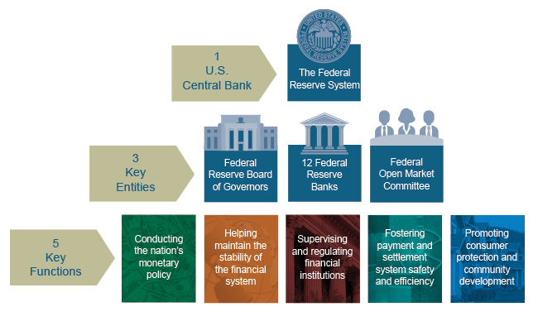

**The Decentralized System Structure**

In establishing the Federal Reserve System, the United States was divided geographically into 12 Districts, each with a separately incorporated Reserve Bank. District boundaries were based on prevailing trade regions that existed in 1913 and related economic considerations, so they do not necessarily coincide with state lines.

**The U.S. Approach to Central Banking**

The framers of the Federal Reserve Act purposely rejected the concept of a single central bank. Instead, they provided for a central banking "system" with three salient features: (1) a central governing Board, (2) a decentralized operating structure of 12 Reserve Banks, and (3) a combination of public and private characteristics.

Although parts of the Federal Reserve System share some characteristics with private-sector entities, the Federal Reserve was established to serve the public interest.

There are three key entities in the Federal Reserve System: The Board of Governors, the Federal Reserve Banks (Reserve Banks), and the Federal Open Market Committee (FOMC). The Board of Governors, an agency of the federal government that reports to and is directly accountable to Congress, provides general guidance for the System and oversees the 12 Reserve Banks.

Within the System, certain responsibilities are shared between the Board of Governors in Washington, D.C., whose members are appointed by the President with the advice and consent of the Senate, and the Federal Reserve Banks and Branches, which constitute the System's operating presence around the country. While the Federal Reserve has frequent communication with executive branch and congressional officials, its decisions are made independently.

**According to the Commerce Department, as of the end of 2020, the banking system in the United States alone had a total of $27.7 trillion in assets**

The U.S. banking system is similar to commercial banks worldwide, with a fundamental role in storing financial assets and facilitating financial transactions. Here’s an overview:

#### Basic Functions

* **Deposits**: Banks accept money from customers (individuals or organizations), allowing withdrawals on demand or after a specified period, sometimes with penalties for early withdrawal.
* **Interest**: Banks may offer interest on deposits, depending on the account type.
* **Lending**: Banks lend deposited money to other individuals and businesses, charging interest on these loans.

#### Profit Mechanism

* **Interest Spread**: Banks profit from the difference between the lower interest rate paid to depositors and the higher interest rate charged to borrowers.

#### Regulatory Requirements

* **Reserves**: Banks are required by regulators to keep a certain amount of capital in reserve to ensure they can meet withdrawal demands and maintain stability. For large U.S. banks, this reserve requirement is typically 10% of their total capital.

#### Unique Feature: Dual Banking System

* **Licensing**: The U.S. employs a dual banking system where banks can be licensed either at the national or state level.
* **Regulation**: Nationally chartered banks are regulated by federal agencies, while state-chartered banks are overseen by state regulatory bodies.

This dual system allows for diverse regulatory oversight and adaptability within the banking sector, making it unique compared to other countries.

**Banking Role in U.S. Economic Growth**

Banking has played a critical role in the economic growth of the U.S. The roles that banks play in the economy are very important and varied.

They help families to better plan their consumption over time by saving and borrowing money, which improves the allocation of limited resources (capital) and allows households to better plan their consumption over time (which improves the allocation of scarce resources).

**Conclusion**

The U.S. banking sector is a multifaceted system comprising a wide array of institutions that range from large multinational banks to small community banks and credit unions. It operates under a robust regulatory framework designed to ensure stability, protect consumers, and promote fair competition. The sector is also continuously evolving with technological advancements and financial innovations that are reshaping the landscape of banking and financial services.